Topic 2
Development of European civilisation
Name: ___________________ ( ) Class: __________

Key Learning Points
- Introduction to classical civilisation
- Legacy of classical civilisation and its significance for today
- Medieval Europe and the making of Christendom
- Civilisation and living: life in the European Medieval Times (Extended part)

Timeline of historical events
Around 3000 BC | Beginning of ancient Greek civilisation in the Aegean region
509 BC | Establishment of the Roman Republic
336 BC | Alexander becoming the ruler of Greece
27 BC | Establishment of the Roman Empire
AD 1 | Birth of Jesus Christ
AD 313 | Christianity becoming legal in the Roman Empire
AD 476 | - Fall of the Western Roman Empire  - Beginning of the Medieval Times in Europe
AD 1215 | Signing of the Magna Carta
AD 1347 | Outbreak of the Black Death

I Introduction to classical civilisation
A Origin of classical civilisation
1. Early civilisations in the Aegean region
- By 3000 BC, the earliest civilisations emerged around the (a) ___Aegean Sea___ of Greece.

2. Birth of classical civilisation
- Since 8th century BC, ancient (b) ___Greek___ civilisation and ancient (c) ___Roman___ civilisation emerged in Europe one after another. Both of them were European (d) ___classical civilisation___ , laying the foundation for Western modern civilisation.

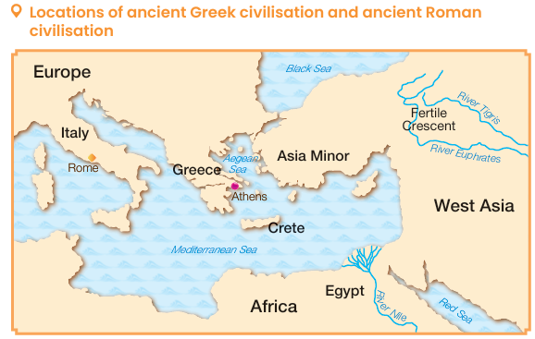 | Being close to the Aegean Sea and the  (e) ___Mediterranean Sea___ , ancient Greek and ancient Roman civilisations considered maritime trade important and extended their influence overseas.

3. Development of classical civilisation: Ancient Greek civilisation
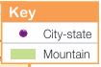
- The terrain of ancient Greece was (a) ___mountainous___ , with few(b) ___plains___  Many small and isolated (c) __city-states__ emerged, with Athens and Sparta being the most famous.  - Curvy coastline  There were many good (d) ___ports___ which benefitted overseas trade development | 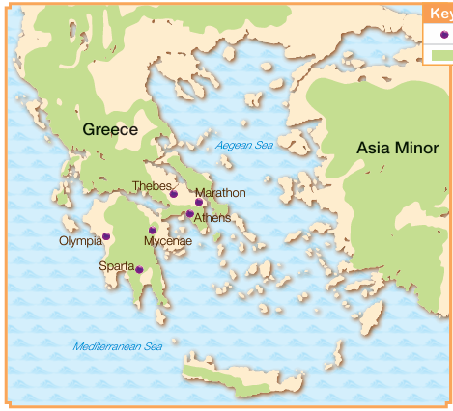

Politics and society of city-states
(e) ___Citizens___  (Male adults who were born in the city-state)  - Granted citizenship  - Being to able to participate in political activities | (f) ___Women___, children and foreigners  - No citizenship | (g) ___Slaves___  - No rights and freedom  - Mostly prisoners of war or poor people in debt.

Foreign expansion of ancient Greek city-states
In mid-5th century BC, (h) ___Athens___ led Greek city-states to defeat the invading (i) ___Persian Empire___ , becoming the leader of Greece.
(j) ___Sparta___ allied with other city-states to attack Athens.
Wars had often broken out among Greek city-states.

Rise and fall of the Alexander's Empire
In 338 BC, the (k) ___Kingdom of Macedonia___ conquered the Greek Peninsula.
In 336 BC, Alexander succeeded to the throne.
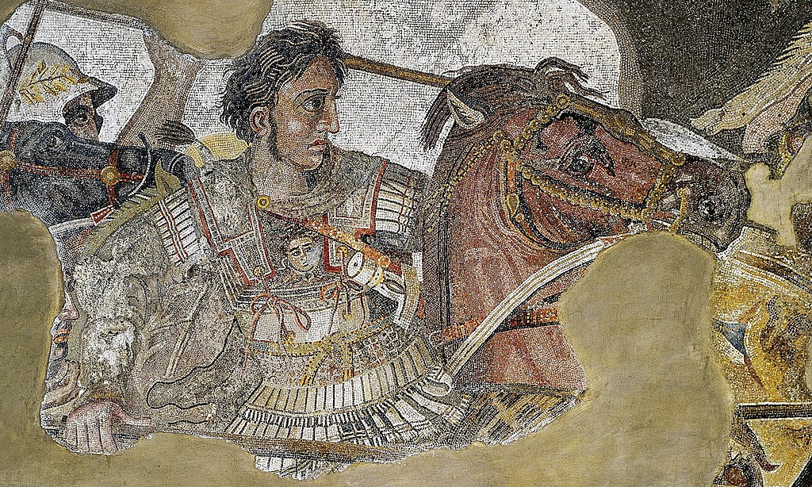
Alexander built the
(l) ___Alexander's Empire___ spanning Europe, Asia and Africa.
In 323 BC, Alexander died of illness. His generals split his empire.
In 146 BC, Greece was conquered by (m) ___Romans___ .

4. Development of classical civilisation: Ancient Roman civilisation
- Around 11th century BC, a tribe of (a) ___Latins___ built many villages along the lower course of the River Tiber in Italy, which later united to establish the (b) ___city of Rome___ .
- In 509 BC, Romans established the (c) ___Roman Republic___ .

Roman Republic (509-27 BC)
Politics of the early Roman Republic
The Roman Republic had adopted (d) ___bicameralism___ :

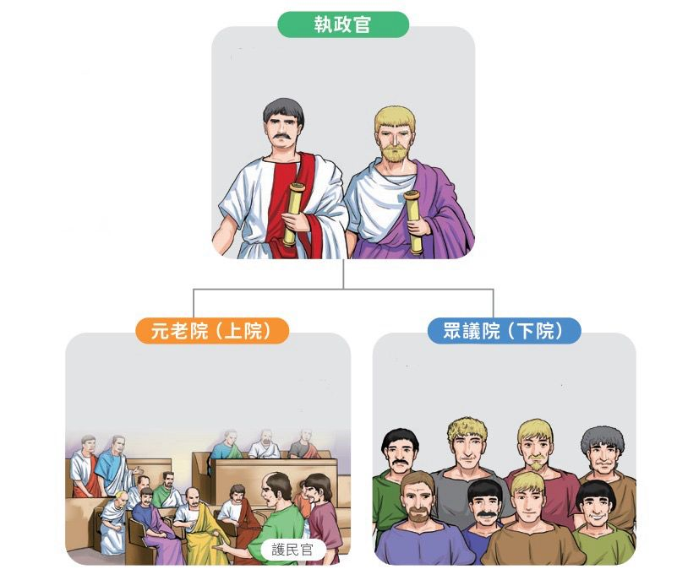
Political affairs were jointly administered by two (e) ___consuls___
- Composition:
It was a newly established body. Most of the members were
(h) ___commoners___ elected by their peers.
- Duties:
Responsible for making laws
- Composition:
The early members were all (f) ___nobles___ and later 2 (g) ___tribunes__ elected by the common people, were added.

- Duties:
Responsible for enacting laws and making diplomatic decisions

Foreign expansion
- To seize control over the Mediterranean region, Rome and (i) ___Carthage___ had fought 3
(j) ___Punic___ Wars.
- After defeating Carthage, Rome conquered most of the regions around the Mediterranean Sea and referred it to ‘ (k) ___Our Sea___ ’.
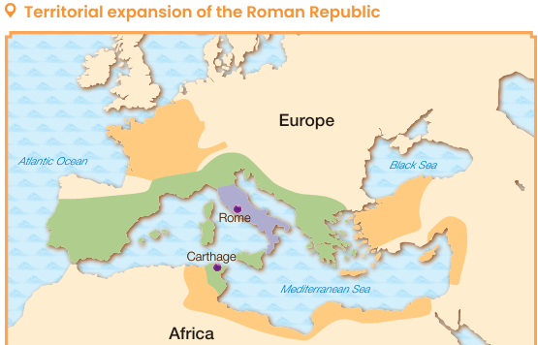
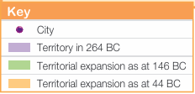
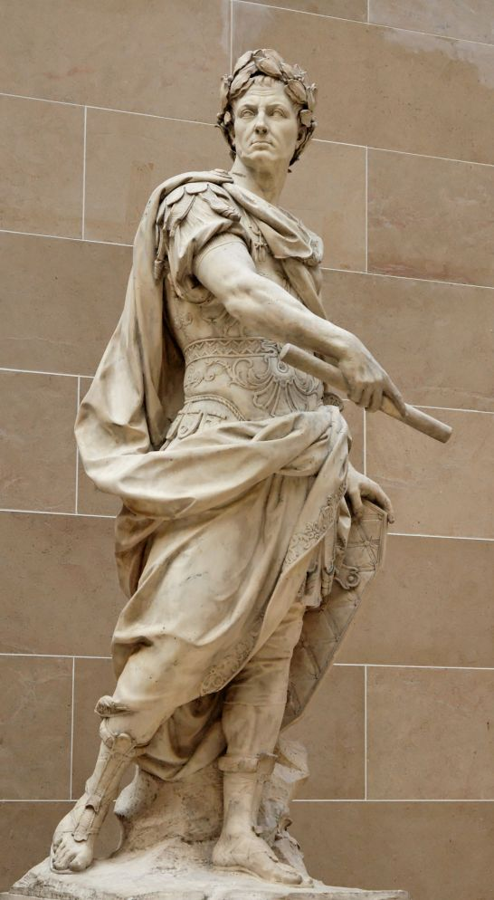 | Dictatorship of Julius Caesar  - In 59 BC, (l) ___Julius Caesar___ became a(m) ___consul___ .  - He led troops to conquer many regions in (n) ___Europe___ and introduced some enlightened reforms.  - In 44 BC, Caesar declared himself the (o) ___dictator for life___ centralising all power in a way that an emperor did. He was assassinated the same year.  The statue of Julius Caesar

Roman Empire (27 BC to AD 476)
Formation  - (p) ___Octavian___ defeated (q) ___Antony___ and became the sole ruler of Rome.  - n 27 BC, the Senate offered Octavian the title of  (r) ___Augustus___ , symbolising the beginning of the Roman Empire. | 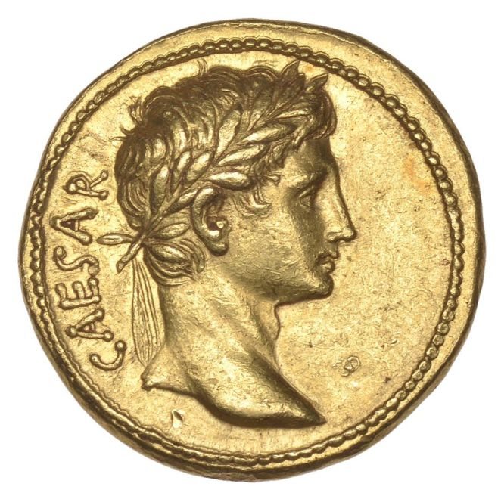  A gold coin made in late 1st century BC to remember Augustus
Peak
The Roman Empire was rich and strong during its first 200 years. Spanning Europe, Asia and Africa, the territory of the Roman Empire was one of the largest in human history.
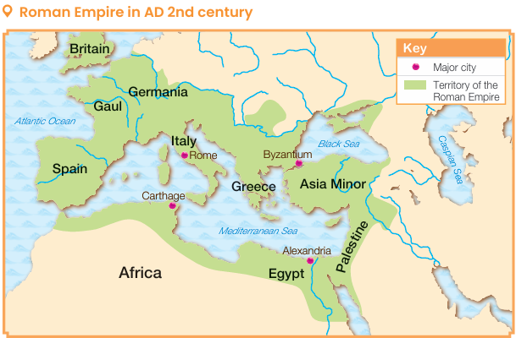
Decline
In AD 395, the Roman Empire was divided into the eastern part and the western part:
Eastern Roman Empire
（Also known as the (t) ___Byzantine Empire___ ）
- Constantinople was the capital
- Eliminated in AD 1453
(s) ___Western Roman Empire___
- Mediolanum was the capital
- Overthrown by the Germanic people in AD 476

II Legacy of classical civilisation and its significance for today
A Governance

Ancient Greece
(a) ___Democracy__ of Athens
- (b) ___Citizens' Assembly___ was the supreme law-making body and the highest organ of power in which all citizens could participate.
- (c) ___Council of Five Hundred___ was an executive body. It was responsible for handling day-to-day city-state affairs.
Became the origin of the (d) ___parliamentary system___
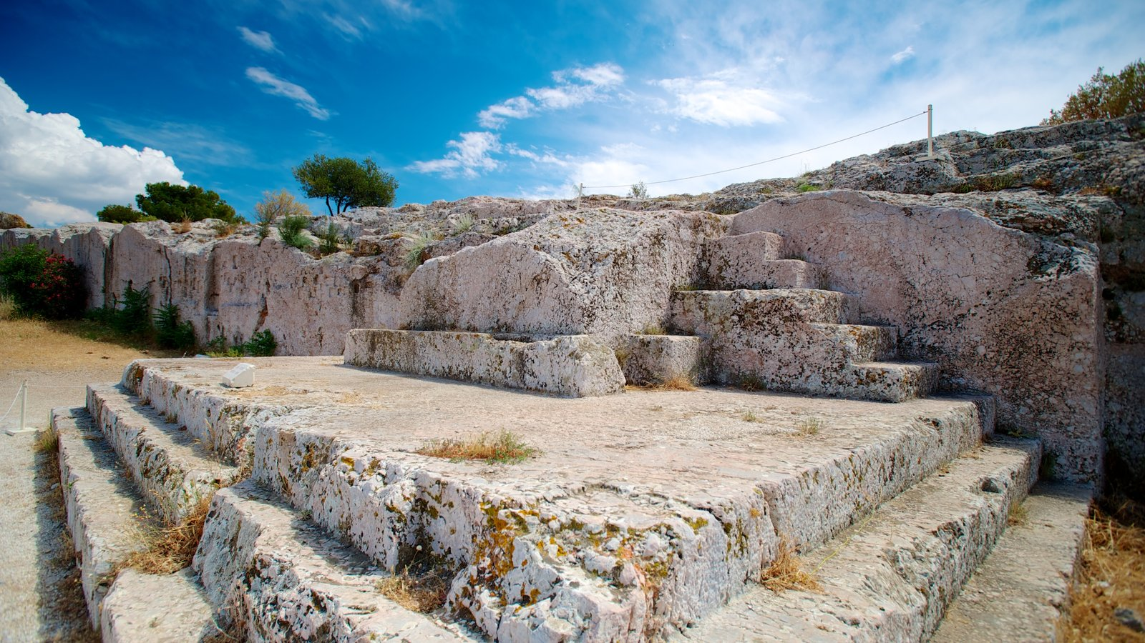
The site where the Athenians used to hold the Citizens' Assembly.
(e) ___Oligarchy___ of Sparta
- Real power rested with the (f) ___Gerousia___ dominated by
(g) ___nobles___
- There were 5 (h) ___ephors___ to supervise the kings and other officials.
It became the model for later (i) ___oligarchy___ .

Roman Republic
- The executive, legislative, and judicial powers belonged to different institutions.
(j) ___Bicameralism___ continues to be widely adopted by countries around the world today.
- Promote equal political rights for both commoners and nobles
Inspired the later republican system that granted (k) ___citizens___ equal chance to political participation.
Roman Empire
(l) The ___emperor___ assumed total power.
(m) ___Empire___ still had far-reaching influence on later generations. Many rulers regarded themselves as the successors of the Roman Empire.

Ancient Rome

B Creation of culture
 | Ancient Greece |  | Ancient Rome
Concept of law | Ancient Greeks put emphasis on the  (a) ___law___ , which laid foundation for later concepts of (b) ___democracy and equality___ in the formation of law. |  | - The (c) ___Law of the Twelve Tables___ protected the rights of the commoners.  - The fundamental spirit of Roman law was that private property should not be violated, and that  (d) ___everyone was equal___ before the law  - Roman law laid the foundation for the future concept of  (e) ___law___ in the Western world.
Myths, religion and thoughts | - Greeks made use of the tales about the gods to create many  (f) ___myths___ , which served as a source of inspiration for future literature.  - Philosophers such as  (g) ___Socrates___ , Plato and Aristotle emerged.  - (h) ___Herodotus___ is known as the ‘father of history’ in the West. |  | - In early days, Romans believed in many gods that were similar to those of Greece.  - From AD 1st century onwards, (i) ___Christianity___ gradually replaced polytheism and has become mainstream in Europe.
Sculptural art | (k) ___Sculptures___ like human statues were very famous in the world. |  | The statues of Roman emperors and (l) ___reliefs___ were very famous in the world.

Architecture, cities and transport | Most of the buildings at the time used stone columns as supports with  (m) ___pediments___ at the top.  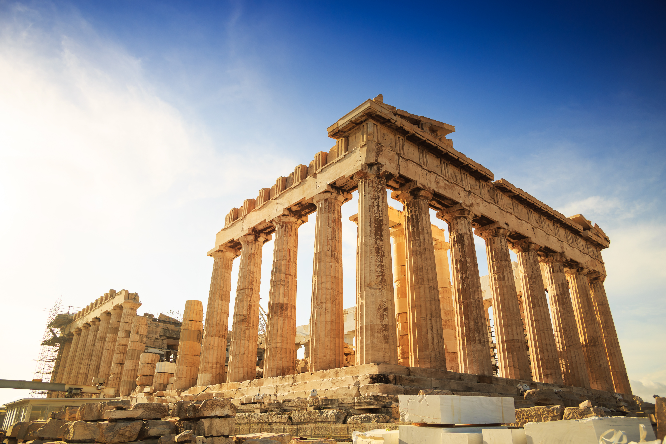  The Parthenon in Athens |  | - Romans adopted ancient Greek architectural elements, and they also formed their own unique style by creating arches and  (n) ___domes___ .  - Roads were flat, straight and dense, forming a complete transportation network.  - (p) ___Aqueducts___ were built to ensure the water supply of cities.  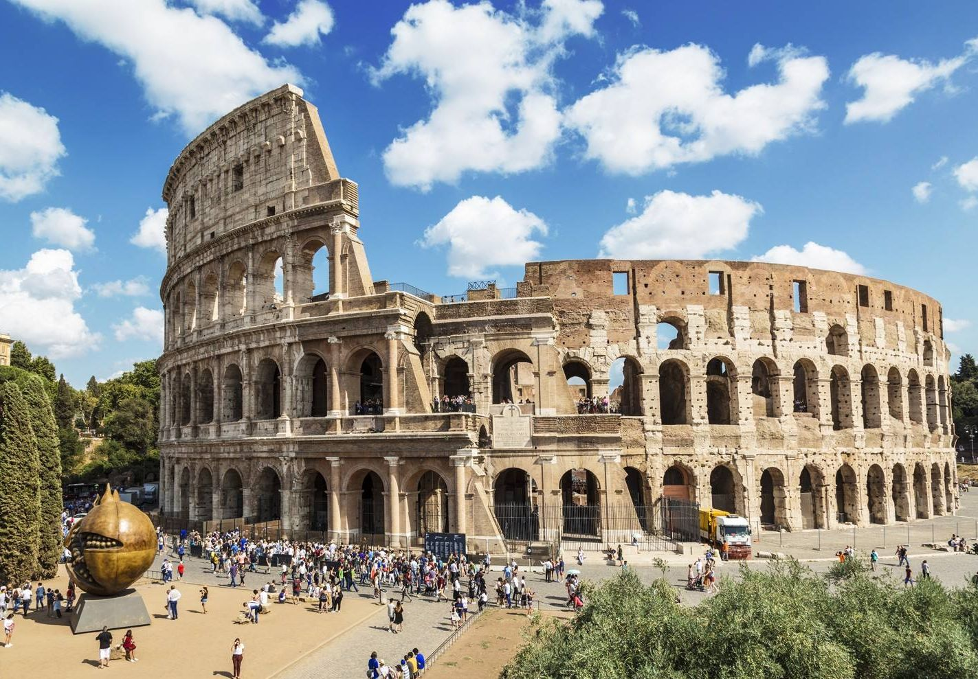  Colosseum
Writing systems and literature | - The Greek writing system were adopted into (q) ___Latin___ , becoming the origin of European languages.  - Homer’s (r) ___epic poems___ had a profound impact on later literature, and various Greek plays also greatly influenced future literary works. |  | - Latin was derived from the ancient Greek alphabets, and it was the origin of European languages.  - (s) ___Roman numerals___ are still used around the world.

Science | - Many great mathematicians and physicists emerged, such as Pythagoras who proposed the  (t) ___Pythagorean theorem___ in geometry, and  (u) ___Archimedes___ who proposed the Archimedes' principle.  - (v) ___Hippocratic Oath___ has become the code of conduct for all Western medical doctors. |  | (w) ___Julian calendar___ became the basis of the Gregorian calendar that is still used globally nowadays.
Sports and entertainment | The ancient (x) ___Olympic Games___ have been passed down to the present day. |  | Romans enjoyed (y) ___gladiator fights___ and other competitions, and they also liked to spend their leisure time by (z) ___baths___ .

III Medieval Europe and the making of Christendom
A Feudal society in medieval Europe
1. What is the Medieval Times?

Wars were frequent in the early period.
The influence of Christianity also reached its peak. Thus, it was also known as (b) ___Christendom___ .
European countries gradually formed (a) ___feudal society___ .

Modern Times
Ancient times
Medieval
Times (AD 476 – 1492)

Columbus discovered the Americas.
The fall of the Western Roman Empire

2. Origins of feudal society
- Feudal society refers to the political and military practice in which a lord granted
(a) ___land___ together with (b) ___peasants___ to his vassals.
- Entering the Medieval Times, the kings of the newly-emerging kingdoms lacked governing power and authority. Therefore, they adopted the form of (c) ___granting fiefs___ , allowing lower-rank (d) ___nobility___ to hold land in exchange for their loyalty and support to the central kingship.
3. Characteristics of feudal society
Clear social divisions
- There was a strict hierarchy of social classes, forming a pyramid-like social structure with the
(a) ___king___ at the top.
- The nobility were
(b) ___ vassals___ of the upper class, but also
(c) ___lords ___ of the lower class. Vassals pledged loyalty only to their immediate lords.
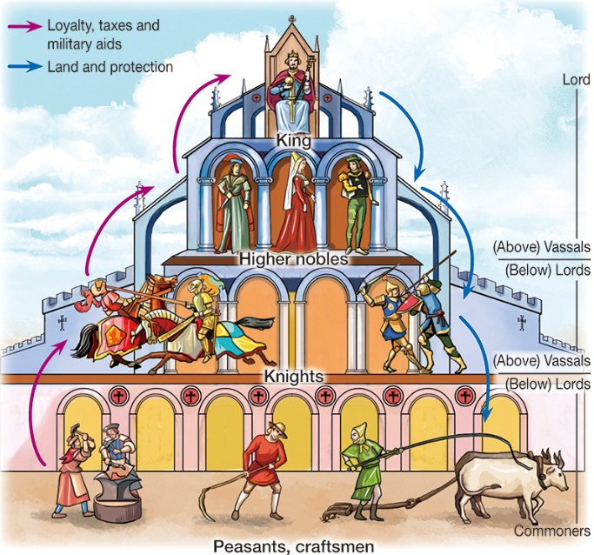

Contract between the lord and the vassal
- The lord granted land and (d) ___protection___ to the vassal.
- The vassal (e) ___pledged loyalty___ to the lord, (f) ___paid taxes___, and provided military service in return.

Hereditary system
- Fiefs were (g) ___hereditary___ but they could not be bought or sold.
- When the vassal passed away, his son would take an oath of loyalty again to the lord, inheriting the (h) ___title___ and (i) ___fief___ .

Manor system
- The (j) ___economic foundation___ of feudal society.
- (k) ___Commoners___ living in the manor were subject to the lord, and they had to farm the lord's land and pay taxes.
- Being (l) ___self-sufficient___ , commercial activities in manors were not common.

Chivalry
- Knights must possess the virtues of integrity, (m) ___courage___ , honesty and humility.
- They swore loyalty to their (n) ___lords___ , emphasised the protection of
(o) ___women___ and the weak.
- Valued their (p) ___honour___ above their lives.

4. Impact of medieval European civilisation on today's world

- The settlement of
(d) ___merchants___ and craftsmen developed into a town.
- Workshops or stores in a particular branch of industry would form a
(e) ___guild___ .
- Bourgeoisie buy a (f) ___charter___ from the lord to obtain rights of
(g) ___self-government___.
Rise of township

- In feudal society, the spirit of
(a) ___contract___ was developed. Both the lord and the vassal agreed on mutual rights and duties.
- In AD 1215, British nobles forced the king to sign the (b) ___Magna Carta___ .It is still the core values of present-day
(c) ___constitution___ .
Spirit of contract and constitution

Since late AD 11th century, European countries had established
(j) ___universities___ became the model of modern universities

Emergence of universities

- In the late Medieval Times, the continuous growth of overseas trade in Europe led to the rise of
(h) ___banking___ .
- The bank run by the Italian
(i) ___Medici family___ was one of the most famous banks in medieval Europe.

Development of banking

B Making of Christendom and the Church in the Medieval Times
Origins of Christianity

Around AD 1, (a) ___Jesus___ was born.
(c) ___Christianity___ started to rise.
Jesus started to spread the gospels when he was 30 years old, and he was called (b) ___Christ___ . He was later crucified on the cross.

Spread and development of Christianity
AD 1st–3rd centuries | After its founding, Christianity was quickly spread across the (d) ___Roman Empire___ , but Christians were cruelly persecuted.
AD 313 | Roman emperor (e) ___Constantine__ recognised the legal status of Christianity.
AD 392 | Christianity became the (f) ___official religion___ of the Roman Empire.
Medieval Times | - The ruler of the Kingdom of the Franks (g) ___Charlemagne___ actively encouraged the conquered people to convert to Christianity.  - In AD mid-11th century, Christianity was divided into two main branches: (h) ___Catholicism___ and (i) ___Eastern Orthodoxy.___ .

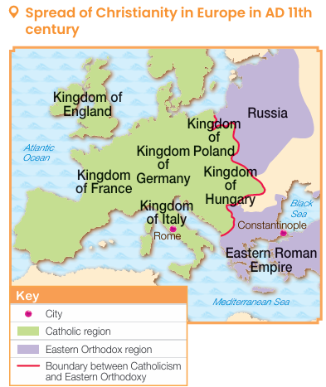
- The Church was the largest
(n) ___landowner___ in medieval Europe.
- The Church collected (o) ___tithes___ from the residents.
- (j) ___Catholicism___ was the official religion of most European kingdoms.
- The (k) ___Pope___ possessed great political influence. He (l) ___crowned___ kings and emperors, enforced the
(m) ___canon law ___ ,etc.

Economic aspect
Political aspect
Roles of the Church in medieval Europe

Cultural and educational aspect
Social aspect

The Church provided (p) ___social benefits___ such as setting up (q) ___shelters___ .
- Most schools were established by the Church. The (r) ___clergy___ taught Latin, theology and other knowledge.
- Artistic works were primarily religious.

C End of the Medieval Times

- Following the rise of (a) ___township___ and the development of commerce,
(b) ___peasants___ moved to towns to work.
- In AD 14th century, the (c) ___Black Death___ broke out in Europe, resulted in a sharp decline in European population and widespread abandoned farmland.
- The manor system collapsed, leading to the end of (d) ___feudal society___ .
Collapse of the manor system

- European monarchs no longer relied on the (e) ___nobility___ 's military service. They reigned over the people directly.
- As the (f) ___contractual___ relationship between the monarch and the nobility ceased to exist, feudal society dissolved.
Advancement to the centralisation of authority

D Civilisation and living: life in the European Medieval Times (Extended part)

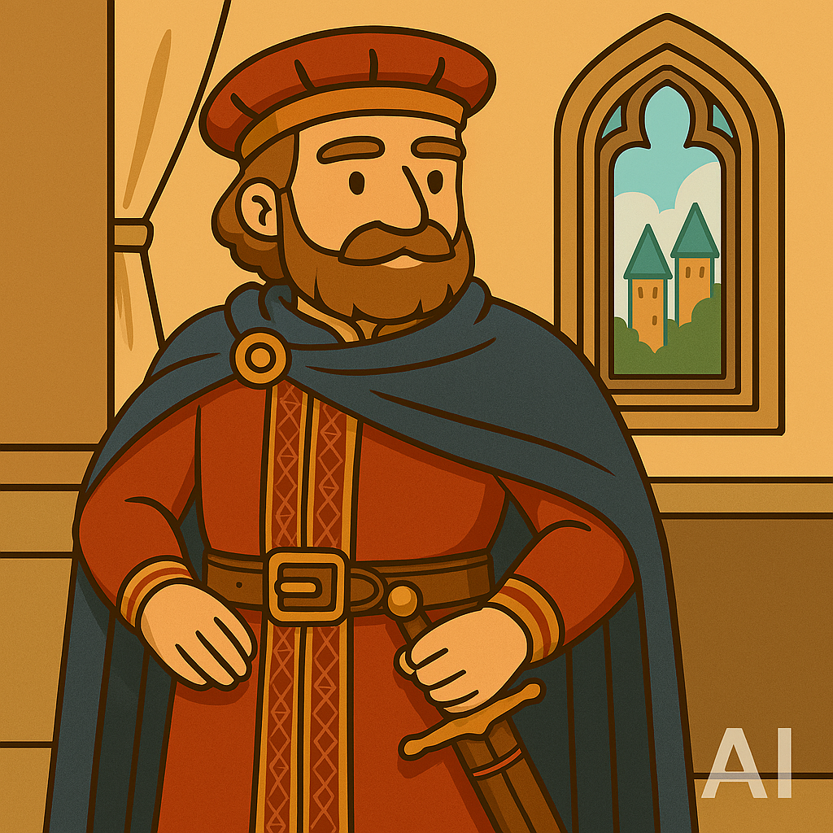  High nobles | - They lived in (a) ___castles___ and led a comfortable life.  - They relied on the crops and rents paid by (b) ___peasants___ , as well as tributes from their vassals.  - They always held large (c) ___feasts___ and balls
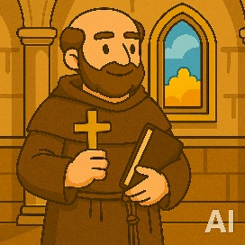  Clergy | - Many (g) ___high clerics___ were lords.  - Middle and low clerics lived a (h) ___hard___ life.  - Monks in the (i) ___monastery___ worked on the land and performed good deeds.
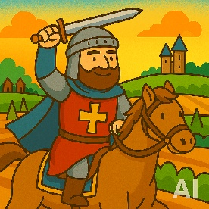  Knights | - They were given a small (d) ___fief___ by the king or the lord. They fought for their lord throughout their lives.  - In wartime, knights fought the enemy. In peacetime, knights guarded the lord's castle and manor and participated in (e) ___jousts___ and tournaments.  - They tried hard to fulfil the code of (f) ___chivalry___ .
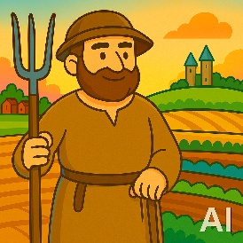  Peasants | - Most peasants were (j) ___serfs___ , they farmed the (k) __lord___ 's land and worked for their lords.  - They could not leave the manor without the lord's permission, and they also needed to pay taxes,leading a hard life.
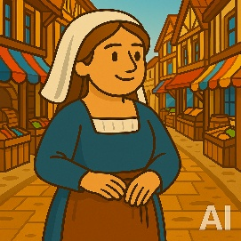  Townspeople | - Their living environment was poor. Houses and streets were narrow and crowded, and the environment was dirty, making it easy for (l) ___infectious diseases to break out.  - Wooden houses were also prone to (m) ___fire___ .

